**DESIGN  
 DOCUMENT**

**for**

**Family Tree Generator**

**Yunus Tufan Bozkurt - 20140602003**

**Umut Kanpalta - 20150602036**

**Berke Parıldar - 20190602031**

**Ozan Yücel – 20190602043**

**Table of Contents**

1. Introduction 3

1.1 Purpose 3

1.2 Scope 3

2. Program Functions and Design 3

2.1 Language and External Tools 3

2.2 Program Capabilities 3

2.3 Component Descomposition 3

3. Visiual Explanations 4

3.1 Use Case Diagram 4

3.2 Class Diagram 4

3.3 Activity Diagrams 4

3.4 Sequance Diagrams 4

**2. Program Functions and Design**

**2.1 Language and External Tools**

Java will be programming language for this project. Swing will be used as GUI library.

**2.2 Program Capabilities**

User can edit family trees, delete family trees, and export or import a family tree via using File I/O. Program also should be able to merge specific two trees (if there is a node in common), find relation between two person, and search family trees or family members.

**3. Visual Explanations**

**3.1 Use Case Diagram**

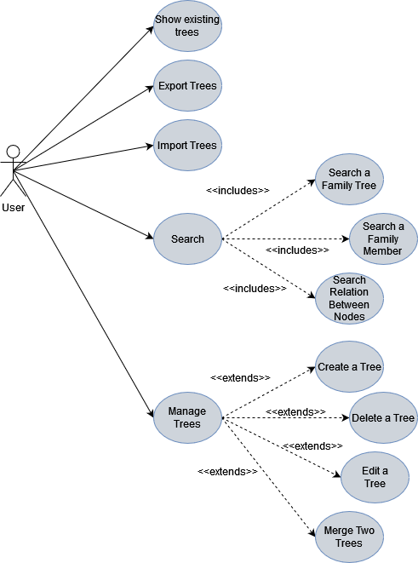

**3.2 Class Diagram**

**3.3 Activity Diagrams**

**Create Family Tree Activity Diagram**

**Delete Family Tree Activity Diagram**

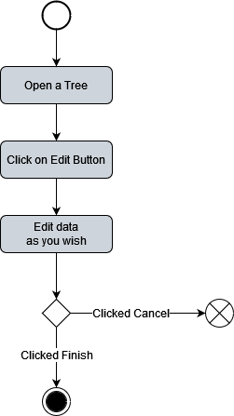

**Edit Family Tree Activity Diagram**

**Merge Family Trees Activity Diagram**

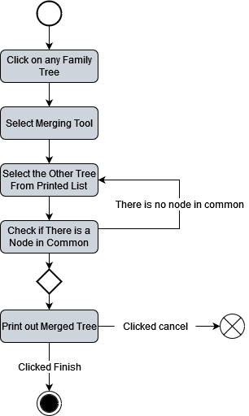

**Open Family Tree Activity Diagram**

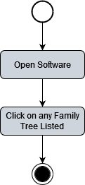

**Relation Finding Activity Diagram**

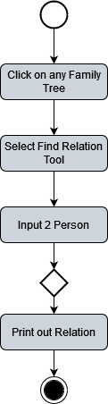

**3.4 Sequence Diagrams**

**Create Family Tree Sequence Diagram**

**Delete Family Tree Sequence Diagram**

**Edit Family Tree Sequence Diagram**

**Open Family Tree Sequence Diagram**

**Merge Family Tree Sequence Diagram**

**Relation Family Tree Sequence Diagram**

